Artificial Intelligence
Machine Learning & Deep Learning

Assignment Title: Linux Commands
Submitted To: Adeel Munir
Submitted By: Atifa Waheed

Linux Commands:
- Command chmod
The chmod command is used to change file and directory permissions in Linux. In Linux, every file has three types of permissions:
- Read (r)
- Write (w)
- Execute (x)
Input Syntax: chmod [permissions] [file/directory]
Output:
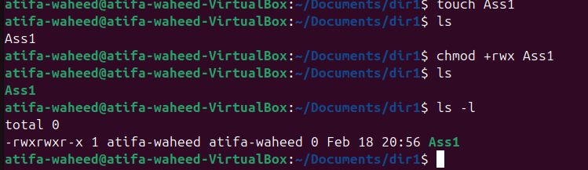
- Command ps
The ps command is used to display currently running processes in the system. It helps us monitor active programs, check background tasks, and debug system performance issues.
Input Syntax: ps aux
Output:
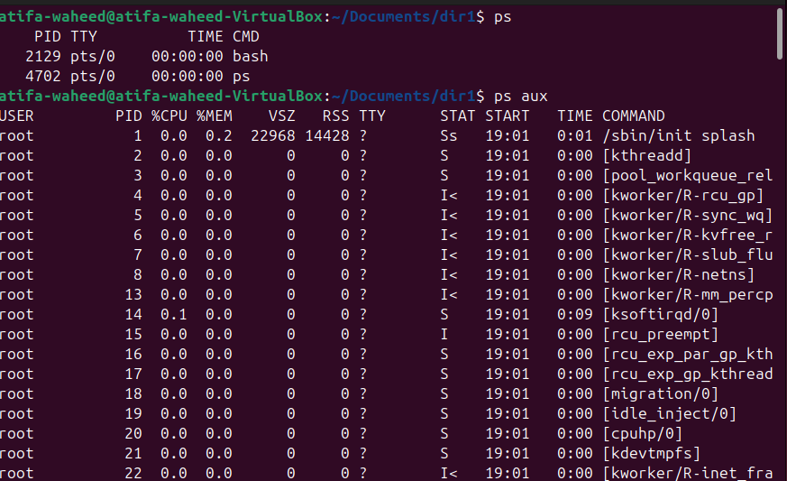
- Command kill ID
The kill command is used to terminate a running process using its Process ID (PID). Sometimes a program becomes unresponsive or consumes too much memory. In that case, we use kill to stop it.
Input Syntax: kill PID
Output:
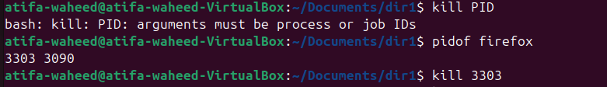
Note: PID can be find out through the syntax pidof [program].
- Command sudo apt update
This command is used to update the package list in Ubuntu or Debian-based Linux systems. It checks for the latest versions of installed software.
Input Syntax: sudo apt update
Output:
